**Significance of the work**

This project aims to address the current limitations and accelerate the “make” aspect of the Design Make Test Analyse (DMTA) cycle for the discovery of antivirals. This project will use low-cost robotics (<10k) and a digitized chemistry platform, Chemist Assisted Robotics (CAR), for the multi-step synthesis of 1000’s of out-of-catalogue compounds. This project aims to make fragment follow-up design cheap (<5k) and rapid (<4 weeks). CAR combines a cloud-based web-application, digitized chemistry (19 reactions tested and encoded), and automated code generation for reviewing, selecting, and executing the automated synthesis of follow-up compounds on a low-cost liquid handler. Follow-up compounds will be designed using a generative algorithm, that uses the power of multiple fragments, to maximize the number of protein interactions, to explore a massive merge-enumeration design space. To fully exploit the merge-design space, this project aims to digitize multi-step chemistry as required, by reaction pathways suggested my Manifold, for the synthesis of merging designs. To mitigate synthetic attrition and enable rapid discovery, the platform will be expanded to execute multiple protocols per reaction type, using the power of automation, to rapidly explore multiple reaction conditions. To avoid costly purification steps, this project will use crude multi-step reaction mixtures, using methodology developed at XChem, to yield large volume structural data to inform iterative design campaigns.

**Significant project-generated resources**

To further accelerate fragment progression, we have been developing the CAR platform (“chemist-assisted robotics”), that combines AI-driven compound design derived and the testing of crude reaction mixtures by XChem. Since CAR can generate 100s-1000s of crude reaction mixtures, this therefore rapidly achieves a first iteration of the Design-Make-Test-Analyse (DMTA) cycle that can yield the volume and quality of data required to ensure the “Analyse” step can progress to high potency with very few (ideally no) additional cycles, using AI-based generative methods. Specifically, CAR currently comprises a cloud-based web-application for curation of reactions; an interface to retrosynthesis engines; digitized chemistry (19 reactions tested and encoded); automated code generation for reviewing, selecting, and executing the automated synthesis of follow-up compounds; protocols for executing code on an OpenTrons low-cost liquid handler; and a QC tool for semi-automated analysis of MS results (Figure 1A). To expand the chemistry repertoire, to increase the exploration of the follow-up chemical space, CAR is engineered to rapidly digitise reaction protocols for rapid exploration of the reaction parameter space (Figure 1B).

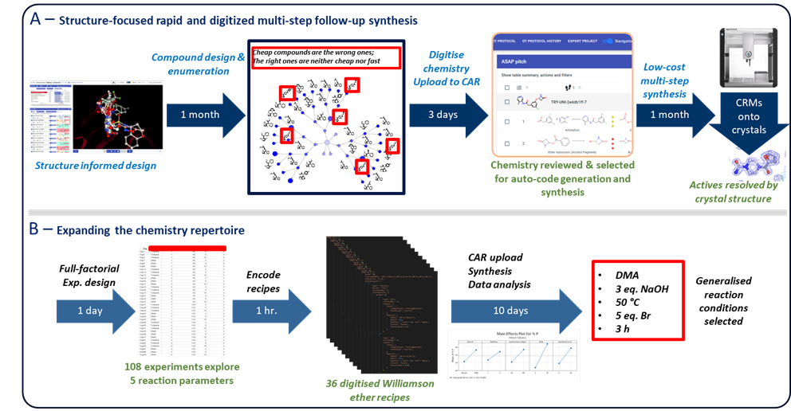

***Figure 1****. (A). CAR is a digitised chemistry platform for the rapid selection of follow-ups for synthesis, via automated code generation, on a low-cost liquid handler. (B) CAR enables rapid exploration of reaction parameters, using full-factorial designs for example, to enable generalisation or fine-tuning of reaction recipes*.

The compound-design, we are additionally developing, seeks to augment the algorithm for pure fragment merges. These use and retain only the original fragment information, and therefore they cannot on their own sufficiently explore the merge-design space, since adding or removing fragment bits may have a significant impact on the structure-activity relationships (SAR), that ideally needs to be understood early in the early discovery.

Instead, we can vastly expand the merge-design space, to “colour in” the SAR (hence “SAR-colouring”). We combine merge-enumeration with retrosynthesis prediction from PostEra’s Manifold tool: the merge algorithm provides the iteration of designs, whereafter each design’s synthetic pathway(s) are enumerated by Manifold, and finally the reactions are elaborated through searching for purchasable analogues of the building blocks and substructure searches (Figure 2A). Finally, the most effective experiments are selected (Figure 2B), and fed to synthesis by CAR.

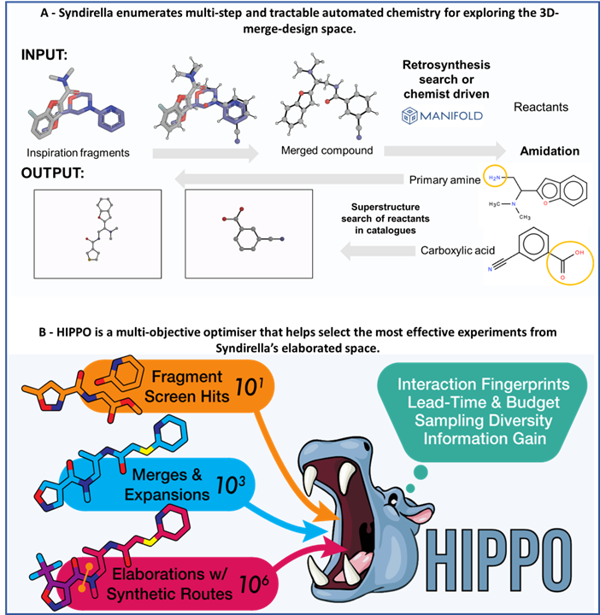

***Figure 2****. (A). Syndirella elaborates multi-step and tractable chemistry for CAR though an exhaustive substructure search, accessed through Postera’s Manifold system, for massively expanding the chemical space for merge-based-designs. (B) HIPPO effectively samples, using a multi-objective optimization of weighted properties such as building block cost, lead time and fragment interactions, for execution on CAR.*

**A. Specific Aims for the MP/DRP**

The Specific Aims have not been modified from the original, competing application.

**B. Studies and Results**

* **Platform primed for ASAP roll-out -** Enumeration and building block selection strategies for automated synthesis, using the Chemist Assisted Robotics (CAR) digitized chemistry system, is ready for rapid, low-cost synthesis of ASAP target follow-ups. The platform is integrating with Project 2’s follow-up design methodologies, with:
  + 96-reactions completed, 46 of which were successfully synthesised with three pre-emptive, pending ongoing data analysis, binding structures (hits) found so far for Enterovirus target ([A71EV2A](https://fragalysis.diamond.ac.uk/viewer/react/preview/target/A71EV2A/tas/lb18145-1)).
  + >120 merge-designs are currently being run through the enumeration and effective experiment selection pipeline for synthesis and structure experiments planned for June 2024.
* **Enumeration** - Syndirella has been developed with Kate Fieseler, a DPhil student co-supervised by Warren Thompson, for the multistep enumeration of CAR friendly reactions. This will massively increase the exploration space around merges, selected from human and algorithmic merge-designs, for follow-up compounds (Figure 3).

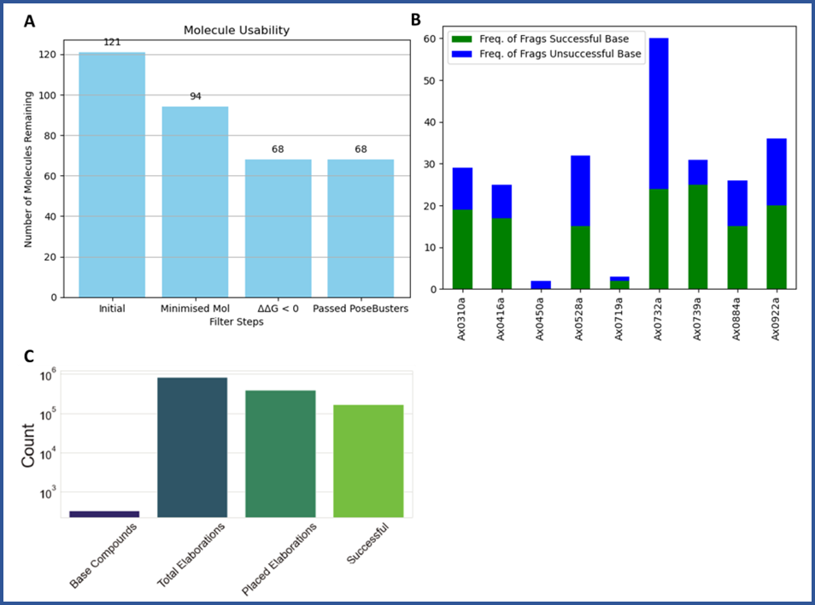

***Figure 3****. (A). Syndirella checks and confirms the poses of the input base-compounds, with 68 base-compounds selected for further elaboration for EV712A. (B) The successful base-compounds covered a very diverse set of fragments from the XChem screen of EV712A. (C) Syndirella explores a massive SAR-like space, increases space by a factor of 1 x 105, around the base-compounds.*

* **Effective experiment selection -** Hit Interaction Profiling for Purchase Optimisation (HIPPO) has been developed, with Max Winokanm, a PDRA from Project 2, for selecting the most effective experiments, that includes a multistep synthesis directed elaboration tool and multi-objective interaction-based optimizer (Cost, lead time, number products) to select the most effective building blocks for rapid SAR follow-up chemistry is ready for deployment on ASAP targets (Figure 4).

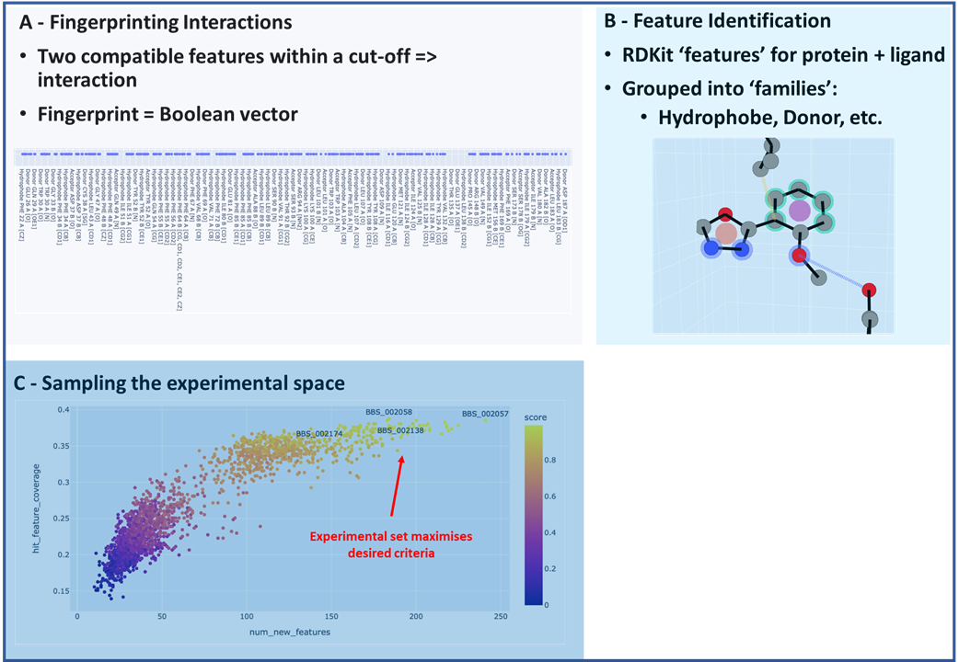

***Figure 4****. (A). HIPPO has been developed assign, map and explore the interaction space of the Syndirella elaborations (B) Ligand-protein interactions can be reviewed in greater detail (C) Multi-objective optimization of; building block cost, lead time, fragment interactions and new interactions are weighted, with weights set as customisable risk factors, is used to explore the potential experimental space and sensibly select the most effective experiments for CAR synthesis.*

* **Automated LCMS Analysis** - Experiments have been performed to validate methodology for defining specifications for the development of MSCheck, an automated LCMS analysis tool being developed by Warren Thompson, for estimating quantitative reaction conversion for the preparation of soaking concentrations for the XChem experiment and eventually estimating kinetic parameters from biophysical experiments.
* **Automated chemistry repertoire expanded -** 17 digitized and tested reaction protocols are ready for rapid follow-up synthesis.

**C. Significance**

This project will use multi-step elaboration and effective experimental selection approaches for execution via low-cost robotics and a digitized chemistry platform to speed up and enable antiviral discovery. A web application will autogenerate robotic code and assist compound section for execution and synthesis on a low-cost liquid handler (<10k). This project aims to make out-of-catalogue compounds cheap (<5k) and rapid (<4 weeks) to harden pandemic preparedness.

**D. Plans**

* **[04/2024]**

Complete multistep synthesis and XChem for >200 follow-ups for Enterovirus target ([EV-A71 2A protease](https://fragalysis.diamond.ac.uk/viewer/react/preview/target/A71EV2A/tas/lb18145-1))

* **[12/2024]**

Biophysical method development (Creoptix) and testing of EV-A71 2A crude reaction mixtures

* **[12/2024]**

To speed up the automated analysis of reactions, estimate concentrations for structural-analysis and biophysics, [MSCheck](https://github.com/Waztom/mscheck) will be developed to include conversion estimates and improved signal-to-product-matching

* **[05/2025]**

Use enumeration and interaction-based building block selection tools for the automated synthesis of follow-up compounds for:

* + One additional ASAP target ([EV-D68 3C protease](https://fragalysis.diamond.ac.uk/viewer/react/preview/target/D68EV3CPROA/tas/lb18145-1) or [Zika NS2BNS3 protease](https://fragalysis.diamond.ac.uk/viewer/react/preview/target/XX01ZVNS2B/tas/lb18145-1))
  + One READDi (An AViDD partner center) target (CHIKV nsp3 Macrodomain) with project started and follow-ups ordered

**Training and Professional Development (For Mentored Projects only)**

Warren Thompson, PhD will be mentored by Frank von Delft, PhD, Lead: Project 2 and Structural Biology Core. Dr. von Delft will work with Dr. Thompson to select target proteins, specifically Project 2 targets that are difficult to progress as TEPs, which Dr. Thompson will use to design follow-up compounds and synthesise using the CAR automated chemistry pipeline ecosystem described in the proposal. Dr. von Delft will guide Dr. Thompson in developing the network-enumeration approach for designing fragment-merges, with particular attention to the selection and prioritization heuristics Dr. Thompson will develop for synthesis using CAR. To ensure Dr. Thompson achieves his project aims within time and budget, Dr. von Delft will mentor Dr. Thompson in project and budget management best practices, as well as people management and leadership with respect to the team that Dr. Thompson will oversee during the project.